UNITED STATES
SECURITIES AND EXCHANGE COMMISSION
Washington, D.C. 20549

FORM 8-K

CURRENT REPORT
Pursuant to Section 13 or 15(d) of the Securities Exchange Act of 1934
Date of Report (Date of earliest event reported): August 19, 2026

UNIFI, INC.
(Exact name of registrant as specified in its charter)

New York |  |  | 1-10542 | 11-2165495
(State or other jurisdiction  of incorporation) |  |  | (Commission File Number) | (IRS Employer  Identification No.)
7201 West Friendly Avenue
Greensboro, North Carolina |  |  |  | 27410
(Address of principal executive offices) |  |  |  | (Zip Code)

Registrant’s telephone number, including area code: (336) 294-4410

Not Applicable
(Former name or former address, if changed since last report)

Check the appropriate box below if the Form 8-K filing is intended to simultaneously satisfy the filing obligation of the registrant under any of the following provisions:
☐Written communications pursuant to Rule 425 under the Securities Act (17 CFR 230.425)
☐Soliciting material pursuant to Rule 14a-12 under the Exchange Act (17 CFR 240.14a-12)
☐Pre-commencement communications pursuant to Rule 14d-2(b) under the Exchange Act (17 CFR 240.14d-2(b))
☐Pre-commencement communications pursuant to Rule 13e-4(c) under the Exchange Act (17 CFR 240.13e-4(c))
Securities registered pursuant to Section 12(b) of the Act:
Title of each class |  | Trading  Symbol(s) |  | Name of each exchange on which registered
Common Stock, par value $0.10 per share |  | UFI |  | New York Stock Exchange
Indicate by check mark whether the registrant is an emerging growth company as defined in Rule 405 of the Securities Act of 1933 (§ 230.405 of this chapter) or Rule 12b-2 of the Securities Exchange Act of 1934 (§ 240.12b-2 of this chapter).
Emerging growth company ☐
If an emerging growth company, indicate by check mark if the registrant has elected not to use the extended transition period for complying with any new or revised financial accounting standards provided pursuant to Section 13(a) of the Exchange Act. ☐

Item 2.02. Results of Operations and Financial Condition.
On August 19, 2026, the Company issued a press release announcing its operating results for the fiscal fourth quarter and fiscal year ended June 28, 2026, a copy of which is attached hereto as Exhibit 99.1.

Item 7.01. Regulation FD Disclosure.
On August 20, 2026, the Company will host a conference call to discuss its operating results for the fiscal fourth quarter and fiscal year ended June 28, 2026. A copy of the materials prepared for use by management during this conference call is attached hereto as Exhibit 99.2.

Item 9.01. Financial Statements and Exhibits.
(d) Exhibits.
Exhibit  No. |  | Description
99.1 |  | Press Release of Unifi, Inc., dated August 19, 2026.
99.2 |  | Earnings Call Presentation Materials.
104 |  | Cover Page Interactive Data File (embedded within the Inline XBRL document).
The information in this Current Report on Form 8-K, including the exhibits attached hereto, is being furnished and shall not be deemed to be “filed” for purposes of Section 18 of the Securities Exchange Act of 1934, as amended (the “Exchange Act”), or otherwise subject to the liabilities of that section, nor shall it be deemed to be incorporated by reference in any filing under the Securities Act of 1933, as amended, or the Exchange Act, except as shall be expressly set forth by specific reference in any such filing.

SIGNATURES
Pursuant to the requirements of the Securities Exchange Act of 1934, the registrant has duly caused this report to be signed on its behalf by the undersigned hereunto duly authorized.
 |  |  | UNIFI, INC.
Date: | August 19, 2026 | By: | /s/ ANDREW J. EAKER
Andrew J. Eaker
Executive Vice President & Chief Financial Officer
Treasurer


Exhibit 99.1
UNIFI®, Makers of REPREVE®, Reports Fourth Quarter Revenue Growth, Higher Margins, and Cash Generation
Fourth quarter revenue growth, disciplined cost execution, and stronger cash generation highlight continued progress in operational turnaround

GREENSBORO, N.C., August 19, 2026 – Unifi, Inc. (NYSE: UFI), the makers of REPREVE® and one of the world’s leading innovators in recycled and synthetic yarns, today released operating results for the fourth fiscal quarter and fiscal year ended June 28, 2026.
Fourth Quarter Fiscal 2026 Highlights
•
Net sales were $144.2 million, an increase of 4.1% from the fourth quarter of fiscal 2025.
•
Revenues from REPREVE Fiber products were $40.2 million and represented 28% of net sales.
•
Gross profit was $14.3 million and gross margin was 9.9%, compared to gross loss of $1.1 million and gross margin of (0.8)% for the fourth quarter of fiscal 2025.
•
SG&A expenses were $11.8 million, a decrease of 1.0% from the fourth quarter of fiscal 2025, primarily driven by cost reduction efforts.
•
Net loss was $1.2 million, or $0.06 per share, compared to net income of $15.5 million, or $0.82 per share, for the fourth quarter of fiscal 2025, which included a $35.8 million gain on the sale of a manufacturing facility, partially offset by $10.6 million in transition costs.
•
Adjusted EBITDA* was $8.2 million, compared to $(4.1) million for the fourth quarter of fiscal 2025.
•
Cash provided by operating activities was $2.1 million during the fourth quarter of fiscal 2026 and $26.5 million during fiscal 2026.
•
Debt principal was $92.4 million and Net Debt* was $67.4 million at June 28, 2026.
•
Following the fourth fiscal quarter, the Company entered into an agreement to sell certain non-strategic real estate assets within the Americas Segment for $60.0 million of gross proceeds. Upon closing, the transaction will significantly enhance financial flexibility, support debt reduction, and further strengthen the balance sheet, with no expected impact on customer service or daily operations.
Eddie Ingle, Chief Executive Officer of Unifi, Inc., stated, “We closed fiscal 2026 with clear momentum, highlighted by meaningful improvement in profitability and cash generation. These results reflect disciplined execution of our cost reduction, operational optimization, and portfolio management initiatives, each of which have driven lower our revenue break-even point. As we enter fiscal 2027, UNIFI is operating from a healthier financial position, with a more focused cost structure and a balance sheet that we expect to further strengthen through the planned sale of non-strategic real estate assets.”

Fourth Quarter Fiscal 2026 Compared to Fourth Quarter Fiscal 2025
Net sales increased to $144.2 million from $138.5 million, primarily due to higher sales from the Brazil Segment, partially offset by tepid customer ordering patterns in the Americas and Asia Segments stemming from geopolitical, trade, and tariff-related uncertainty.
Gross profit increased to $14.3 million from $(1.1) million. Americas Segment gross profit increased by $8.6 million, primarily as a result of multi-year cost reduction efforts. Brazil Segment gross profit increased by $6.4 million, primarily due to favorable pricing dynamics. Asia Segment gross profit increased by $0.5 million, primarily due to an improved sales mix.
Operating income was $2.4 million, compared to $15.1 million in the prior period, primarily reflecting the absence of the gain from the sale of a manufacturing facility recognized in the fourth quarter of fiscal 2025, which was partially offset by transition costs.
Net loss was $1.2 million compared to net income of $15.5 million, which included a gain in fiscal 2025. Adjusted EBITDA* was $8.2 million, a significant increase versus $(4.1) million in the fourth quarter of fiscal 2025.
Fiscal 2026 Compared to Fiscal 2025
•
Gross margin improved 420 basis points, from 1.5% to 5.7%.
•
SG&A expenses decreased $4.3 million, from $49.0 million to $44.7 million.
•
Debt principal declined $15.6 million, from $108.0 million to $92.4 million.
•
Cash provided by operating activities increased $47.8 million, from $(21.3) million to $26.5 million.
•
Capital expenditures decreased $5.5 million, from $10.5 million to $5.0 million.
Fiscal 2027 and First Quarter Outlook
During fiscal 2027, the Company expects:
•
To focus on leveraging its improved cost footprint while investing in innovation.
•
Managing the balance sheet to ensure that the Company remains better positioned to capitalize on improved business conditions and grow over time.
•
Sales and profitability to improve from fiscal 2026 as the Company realizes full-year benefits from portfolio management actions, cost containment initiatives, and improved operating execution.

During the first quarter of fiscal 2027, the Company expects year-over-year segment results as follows:
•
Brazil Segment sales and profitability to improve as the Company leverages its competitive position and advantageous supply chain dynamics.
•
The Asia Segment will remain pressured due to regional softness and geopolitical volatility.
•
Cost savings and stable demand will increase profitability in the Americas Segment with continued growth in margin accretive revenues from value-added products and Beyond Apparel initiatives.
Ingle concluded, “As we enter fiscal 2027, we are seeing encouraging signs across several areas of our business, including Beyond Apparel, which continues to contribute to our improving financial performance. We remain focused on positioning the business for long-term growth, driving disciplined capital allocation, and executing additional initiatives designed to further strengthen our businesses. While UNIFI has entered the new fiscal year in a position of greater financial strength, our focus remains on executing our strategy, serving our customers, and building on the momentum that we have established that will help create long-term value for our shareholders.”
* Adjusted Net Income (Loss), Adjusted EBITDA, and Net Debt are non-GAAP financial measures. The schedules included in this press release reconcile each non-GAAP financial measure to its most directly comparable GAAP financial measure.

Fourth Quarter Fiscal 2026 Earnings Conference Call
UNIFI will provide additional commentary regarding its fourth quarter and fiscal 2026 results and other developments during its earnings conference call on August 20, 2026, at 8:30 a.m., Eastern Time. The call can be accessed via a live audio webcast on UNIFI’s website at http://investor.unifi.com. Additional supporting materials and information related to the call will also be available on UNIFI’s website.
###

About UNIFI
UNIFI, Inc. (NYSE: UFI) is a global leader in fiber science and sustainable synthetic textiles. Using proprietary recycling technology, UNIFI is a pioneer in scaling the transformation of post-industrial and post-consumer waste into sustainable products. Through REPREVE, the world’s leading brand of traceable, recycled fiber and resin, UNIFI is changing the way industries think about the materials they use – and reuse. A vertically-integrated manufacturer, the company has direct operations in the United States, Colombia, El Salvador, and Brazil, and sales offices all over the world. UNIFI envisions a future where circular and sustainable solutions are the only choice. For more information about UNIFI, visit www.unifi.com.
About REPREVE®
Made by UNIFI, Inc. (NYSE: UFI), REPREVE® is the global leader in recycled performance fibers and resins. Using proprietary recycling technology, REPREVE leverages multiple waste sources, including single-use plastic bottles, ocean-bound plastic, textile waste, and recycled yarn. REPREVE has transformed more than 46 billion plastic bottles and 1 billion T-shirts’ worth of textile waste into recycled fiber, powering globally scalable products for world-leading brands. Made traceable with FiberPrint® technology and certified by U-TRUST®, REPREVE spans apparel, footwear, furnishings, industrial, medical, military, mobility, and packaging. For more information about REPREVE, visit www.repreve.com.

Contact information:
Josh Carroll or Chris Hodges
Alpha IR Group
312-445-2870
UFI@alpha-ir.com

Financial Statements, Business Segment Information and Reconciliations of Reported Results to Adjusted Results to Follow

CONDENSED CONSOLIDATED STATEMENTS OF OPERATIONS
(Unaudited)
(In thousands, except per share amounts)

 |  | For the Three Months Ended |  |  |  |  |  |  |  | For the Fiscal Year Ended
 |  | June 28, 2026 |  |  |  | June 29, 2025 |  |  |  | June 28, 2026 |  |  |  | June 29, 2025
Net sales |  | $ | 144,224 |  |  | $ | 138,535 |  |  | $ | 531,303 |  |  | $ | 571,344
Cost of sales |  |  | 129,883 |  |  |  | 139,664 |  |  |  | 500,847 |  |  |  | 562,926
Gross profit (loss) |  |  | 14,341 |  |  |  | (1,129 | ) |  |  | 30,456 |  |  |  | 8,418
Selling, general and administrative expenses |  |  | 11,832 |  |  |  | 11,947 |  |  |  | 44,681 |  |  |  | 49,005
Provision (benefit) for bad debts |  |  | 88 |  |  |  | (127 | ) |  |  | (156 | ) |  |  | (166 | )
Restructuring costs, net |  |  | — |  |  |  | 7,604 |  |  |  | 1,853 |  |  |  | 8,924
Gain on sales and disposals of assets |  |  | (4 | ) |  |  | (35,783 | ) |  |  | (4 | ) |  |  | (40,079 | )
Other operating expense (income), net |  |  | 47 |  |  |  | 110 |  |  |  | (1,270 | ) |  |  | 254
Operating income (loss) |  |  | 2,378 |  |  |  | 15,120 |  |  |  | (14,648 | ) |  |  | (9,520 | )
Interest income |  |  | (397 | ) |  |  | (256 | ) |  |  | (1,691 | ) |  |  | (888 | )
Interest expense |  |  | 1,441 |  |  |  | 2,198 |  |  |  | 6,805 |  |  |  | 9,520
Equity in (earnings) loss of unconsolidated affiliates |  |  | (23 | ) |  |  | 10 |  |  |  | 266 |  |  |  | 477
Income (loss) before income taxes |  |  | 1,357 |  |  |  | 13,168 |  |  |  | (20,028 | ) |  |  | (18,629 | )
Provision (benefit) for income taxes |  |  | 2,550 |  |  |  | (2,302 | ) |  |  | 4,534 |  |  |  | 1,719
Net (loss) income |  | $ | (1,193 | ) |  | $ | 15,470 |  |  | $ | (24,562 | ) |  | $ | (20,348 | )
Net (loss) income per common share:
Basic |  | $ | (0.06 | ) |  | $ | 0.84 |  |  | $ | (1.33 | ) |  | $ | (1.11 | )
Diluted |  | $ | (0.06 | ) |  | $ | 0.82 |  |  | $ | (1.33 | ) |  | $ | (1.11 | )
Weighted average common shares outstanding:
Basic |  |  | 18,587 |  |  |  | 18,361 |  |  |  | 18,488 |  |  |  | 18,314
Diluted |  |  | 18,587 |  |  |  | 18,940 |  |  |  | 18,488 |  |  |  | 18,314

CONDENSED CONSOLIDATED BALANCE SHEETS
(Unaudited)
(In thousands)

 |  | June 28, 2026 |  |  |  | June 29, 2025
ASSETS
Cash and cash equivalents |  | $ | 25,072 |  |  | $ | 22,664
Receivables, net |  |  | 76,666 |  |  |  | 75,383
Inventories |  |  | 101,067 |  |  |  | 122,929
Income taxes receivable |  |  | 905 |  |  |  | 5,429
Other current assets |  |  | 7,743 |  |  |  | 9,222
Total current assets |  |  | 211,453 |  |  |  | 235,627
Property, plant and equipment, net |  |  | 158,325 |  |  |  | 172,923
Operating lease assets |  |  | 6,532 |  |  |  | 7,879
Deferred income taxes |  |  | 5,316 |  |  |  | 5,535
Other non-current assets |  |  | 4,807 |  |  |  | 4,904
Total assets |  | $ | 386,433 |  |  | $ | 426,868
LIABILITIES AND SHAREHOLDERS’ EQUITY
Accounts payable |  | $ | 31,151 |  |  | $ | 37,468
Income taxes payable |  |  | 656 |  |  |  | 49
Current operating lease liabilities |  |  | 2,128 |  |  |  | 2,368
Current portion of long-term debt |  |  | 12,371 |  |  |  | 12,159
Other current liabilities |  |  | 17,249 |  |  |  | 18,899
Total current liabilities |  |  | 63,555 |  |  |  | 70,943
Long-term debt |  |  | 79,998 |  |  |  | 95,727
Non-current operating lease liabilities |  |  | 4,458 |  |  |  | 5,614
Deferred income taxes |  |  | 997 |  |  |  | 1,224
Other long-term liabilities |  |  | 5,203 |  |  |  | 3,889
Total liabilities |  |  | 154,211 |  |  |  | 177,397
Commitments and contingencies
Common stock |  |  | 1,859 |  |  |  | 1,836
Capital in excess of par value |  |  | 77,174 |  |  |  | 74,095
Retained earnings |  |  | 214,487 |  |  |  | 239,049
Accumulated other comprehensive loss |  |  | (61,298 | ) |  |  | (65,509 | )
Total shareholders’ equity |  |  | 232,222 |  |  |  | 249,471
Total liabilities and shareholders’ equity |  | $ | 386,433 |  |  | $ | 426,868

CONDENSED CONSOLIDATED STATEMENTS OF CASH FLOWS
(Unaudited)
(In thousands)

 |  | For the Fiscal Year Ended
 |  | June 28, 2026 |  |  |  | June 29, 2025
Cash and cash equivalents at beginning of year |  | $ | 22,664 |  |  | $ | 26,805
Operating activities:
Net loss |  |  | (24,562 | ) |  |  | (20,348 | )
Adjustments to reconcile net loss to net cash provided (used) by operating activities:
Equity in loss of unconsolidated affiliates |  |  | 266 |  |  |  | 477
Depreciation and amortization expense |  |  | 24,050 |  |  |  | 25,284
Non-cash compensation expense |  |  | 3,352 |  |  |  | 3,252
Gain on foreign currency transaction, net |  |  | (1,892 | ) |  |  | —
Gain on sales and disposals of assets |  |  | (119 | ) |  |  | (39,317 | )
Deferred income taxes |  |  | 235 |  |  |  | (676 | )
Other, net |  |  | (28 | ) |  |  | 160
Changes in assets and liabilities |  |  | 25,232 |  |  |  | 9,857
Net cash provided (used) by operating activities |  |  | 26,534 |  |  |  | (21,311 | )
Investing activities:
Capital expenditures |  |  | (5,002 | ) |  |  | (10,488 | )
Proceeds from sale of assets |  |  | 552 |  |  |  | 51,553
Net cash (used) provided by investing activities |  |  | (4,450 | ) |  |  | 41,065
Financing activities:
Proceeds from long-term debt |  |  | 134,800 |  |  |  | 212,551
Payments on long-term debt |  |  | (154,411 | ) |  |  | (236,544 | )
Other, net |  |  | (250 | ) |  |  | (428 | )
Net cash used by financing activities |  |  | (19,861 | ) |  |  | (24,421 | )
Effect of exchange rate changes on cash and cash equivalents |  |  | 185 |  |  |  | 526
Net increase (decrease) in cash and cash equivalents |  |  | 2,408 |  |  |  | (4,141 | )
Cash and cash equivalents at end of year |  | $ | 25,072 |  |  | $ | 22,664

BUSINESS SEGMENT INFORMATION
(Unaudited)
(In thousands)
Net sales and gross profit (loss) details for each reportable segment of UNIFI are as follows:
 |  | For the Three Months Ended |  |  |  |  |  |  |  | For the Fiscal Year Ended
 |  | June 28, 2026 |  |  |  | June 29, 2025 |  |  |  | June 28, 2026 |  |  |  | June 29, 2025
Americas |  | $ | 84,438 |  |  | $ | 85,009 |  |  | $ | 325,210 |  |  | $ | 347,931
Brazil |  |  | 33,947 |  |  |  | 28,810 |  |  |  | 115,148 |  |  |  | 118,726
Asia |  |  | 25,839 |  |  |  | 24,716 |  |  |  | 90,945 |  |  |  | 104,687
Consolidated net sales |  | $ | 144,224 |  |  | $ | 138,535 |  |  | $ | 531,303 |  |  | $ | 571,344

 |  | For the Three Months Ended |  |  |  |  |  |  |  | For the Fiscal Year Ended
 |  | June 28, 2026 |  |  |  | June 29, 2025 |  |  |  | June 28, 2026 |  |  |  | June 29, 2025
Americas |  | $ | 3,301 |  |  | $ | (5,342 | ) |  | $ | 4,813 |  |  | $ | (20,217 | )
Brazil |  |  | 7,672 |  |  |  | 1,316 |  |  |  | 14,140 |  |  |  | 16,027
Asia |  |  | 3,368 |  |  |  | 2,897 |  |  |  | 11,503 |  |  |  | 12,608
Consolidated gross profit (loss) |  | $ | 14,341 |  |  | $ | (1,129 | ) |  | $ | 30,456 |  |  | $ | 8,418

RECONCILIATIONS OF REPORTED RESULTS TO ADJUSTED RESULTS
(Unaudited)
(In thousands)

EBITDA and Adjusted EBITDA (Non-GAAP Financial Measures)
The reconciliations of the amounts reported under U.S. generally accepted accounting principles (“GAAP”) for Net (loss) income to EBITDA and Adjusted EBITDA are set forth below.

 |  | For the Three Months Ended |  |  |  |  |  |  |  | For the Fiscal Year Ended
 |  | June 28, 2026 |  |  |  | June 29, 2025 |  |  |  | June 28, 2026 |  |  |  | June 29, 2025
Net (loss) income |  | $ | (1,193 | ) |  | $ | 15,470 |  |  | $ | (24,562 | ) |  | $ | (20,348 | )
Interest expense, net |  |  | 1,044 |  |  |  | 1,942 |  |  |  | 5,114 |  |  |  | 8,632
Provision (benefit) for income taxes |  |  | 2,550 |  |  |  | (2,302 | ) |  |  | 4,534 |  |  |  | 1,719
Depreciation and amortization expense (1) |  |  | 5,894 |  |  |  | 6,018 |  |  |  | 23,820 |  |  |  | 25,064
EBITDA |  |  | 8,295 |  |  |  | 21,128 |  |  |  | 8,906 |  |  |  | 15,067
Transition costs (2) |  |  | — |  |  |  | 10,585 |  |  |  | 1,068 |  |  |  | 13,485
Gain on foreign currency transaction, net (3) |  |  | (117 | ) |  |  | — |  |  |  | (1,892 | ) |  |  | —
Gain on sales of assets (4) |  |  | — |  |  |  | (35,807 | ) |  |  | — |  |  |  | (40,103 | )
Restructuring costs (5) |  |  | — |  |  |  | — |  |  |  | 785 |  |  |  | —
Adjusted EBITDA |  | $ | 8,178 |  |  | $ | (4,094 | ) |  | $ | 8,867 |  |  | $ | (11,551 | )

(1)
Within this reconciliation, depreciation and amortization expense excludes the amortization of debt issuance costs, which are reflected in interest expense, net. However, within the accompanying Condensed Consolidated Statements of Cash Flows, amortization of debt issuance costs is reflected in depreciation and amortization expense.
(2)
In the first quarter of fiscal 2026, UNIFI incurred various transition costs totaling $1,068 in connection with the consolidation of its yarn manufacturing operations including (i) facility closure and equipment relocation costs (including asset impairments and disposals) of $1,021, and (ii) employee separation costs of $47. The facility closure, equipment relocation, and employee separation costs were all recorded within Restructuring costs in the Condensed Consolidated Statements of Operations. In fiscal 2025, UNIFI incurred various transition costs totaling $10,585 for the fourth quarter of fiscal 2025 and $13,485 for fiscal 2025 in connection with the consolidation of its yarn manufacturing operations including (i) facility closure and equipment relocation costs (including asset impairments and disposals) of $4,808 and $5,896, respectively, (ii) inventory write-downs of $1,924 and $2,923, respectively, (iii) excess fixed manufacturing costs of $1,058 and $1,638, respectively, and (iv) employee separation or retention costs of $1,347 and $1,580, respectively, and (v) forfeitures of deposits for texturing machinery of $1,448 and $1,448, respectively. The facility closure, equipment relocation, employee separation and retention costs, and forfeitures of deposits were all recorded within Restructuring costs and the inventory write-downs and excess fixed manufacturing costs were recorded within Cost of sales in the Condensed Consolidated Statements of Operations.
(3)
In fiscal 2026, UNIFI recorded a foreign currency gain of $117 in the fourth quarter of fiscal 2026 and $1,892 for fiscal 2026. In December 2025, Brazil declared dividends against the majority of its retained earnings in connection with certain tax law changes related to future dividends. Foreign currency transaction gains (losses) are recorded to reflect changes in the exchange rate of the Brazilian Real to the U.S. Dollar while the dividend payable is outstanding.
(4)
In the second quarter of fiscal 2025, UNIFI recorded a gain of $4,296 related to the sale of a warehouse located in Yadkinville, North Carolina. In the fourth quarter of fiscal 2025, UNIFI recorded a gain of $35,807 related to the sale of a manufacturing facility in Madison, North Carolina.
(5)
In the second quarter of fiscal 2026, UNIFI recorded employee separation costs of $1,093 in connection with the Fiscal 2026 Profit Improvement Plan and a $308 gain from disposals of assets from the consolidation of Americas yarn manufacturing operations.

Adjusted Net (Loss) Income and Adjusted EPS (Non-GAAP Financial Measures)
The tables below set forth reconciliations of (i) Income (loss) before income taxes (“Pre-tax Income (Loss)”), (ii) Provision (benefit) for income taxes (“Tax Impact”), (iii) Net (loss) income (“Net (Loss) Income”) to Adjusted Net (Loss) Income, and (iv) Diluted Earnings Per Share (“Diluted EPS”) to Adjusted EPS. Rounding may impact certain of the below calculations.

 |  | For the Three Months Ended June 28, 2026 |  |  |  |  |  |  |  |  |  |  |  |  |  |  |  | For the Three Months Ended June 29, 2025
 |  | Pre-tax Income |  |  |  | Tax Impact |  |  |  | Net Loss |  |  |  | Diluted EPS |  |  |  | Pre-tax Income (Loss) |  |  |  | Tax Impact |  |  |  | Net Income (Loss) |  |  |  | Diluted EPS
GAAP results |  | $ | 1,357 |  |  | $ | (2,550 | ) |  | $ | (1,193 | ) |  | $ | (0.06 | ) |  | $ | 13,168 |  |  | $ | 2,302 |  |  | $ | 15,470 |  |  | $ | 0.82
Transition costs (1) |  |  | — |  |  |  | — |  |  |  | — |  |  |  | — |  |  |  | 10,585 |  |  |  | — |  |  |  | 10,585 |  |  |  | 0.56
Gain on foreign currency transaction, net (2) |  |  | (117 | ) |  |  | 216 |  |  |  | 99 |  |  |  | — |  |  |  | — |  |  |  | — |  |  |  | — |  |  |  | —
Gain on sale of assets (3) |  |  | — |  |  |  | — |  |  |  | — |  |  |  | — |  |  |  | (35,807 | ) |  |  | — |  |  |  | (35,807 | ) |  |  | (1.89 | )
Recovery of income taxes (4) |  |  | — |  |  |  | — |  |  |  | — |  |  |  | — |  |  |  | — |  |  |  | (893 | ) |  |  | (893 | ) |  |  | (0.05 | )
Adjusted results |  | $ | 1,240 |  |  | $ | (2,334 | ) |  | $ | (1,094 | ) |  | $ | (0.06 | ) |  | $ | (12,054 | ) |  | $ | 1,409 |  |  | $ | (10,645 | ) |  | $ | (0.56 | )
Weighted average common shares outstanding |  |  |  |  |  |  |  |  |  |  |  |  |  |  | 18,587 |  |  |  |  |  |  |  |  |  |  |  |  |  |  |  | 18,940
 |  | For the Fiscal Year Ended June 28, 2026 |  |  |  |  |  |  |  |  |  |  |  |  |  |  |  | For the Fiscal Year Ended June 29, 2025
 |  | Pre-tax Loss |  |  |  | Tax Impact |  |  |  | Net Loss |  |  |  | Diluted EPS |  |  |  | Pre-tax Loss |  |  |  | Tax Impact |  |  |  | Net Loss |  |  |  | Diluted EPS
GAAP results |  | $ | (20,028 | ) |  | $ | (4,534 | ) |  | $ | (24,562 | ) |  | $ | (1.33 | ) |  | $ | (18,629 | ) |  | $ | (1,719 | ) |  | $ | (20,348 | ) |  | $ | (1.11 | )
Transition costs (1) |  |  | 1,068 |  |  |  | — |  |  |  | 1,068 |  |  |  | 0.06 |  |  |  | 13,485 |  |  |  | — |  |  |  | 13,485 |  |  |  | 0.74
Gain on foreign currency transaction, net (2) |  |  | (1,892 | ) |  |  | 488 |  |  |  | (1,404 | ) |  |  | (0.07 | ) |  |  | — |  |  |  | — |  |  |  | — |  |  |  | —
Gain on sales of assets (3) |  |  | — |  |  |  | — |  |  |  | — |  |  |  | — |  |  |  | (40,103 | ) |  |  | — |  |  |  | (40,103 | ) |  |  | (2.19 | )
Recovery of income taxes (4) |  |  | — |  |  |  | — |  |  |  | — |  |  |  | — |  |  |  | — |  |  |  | (893 | ) |  |  | (893 | ) |  |  | (0.05 | )
Restructuring costs, net (5) |  |  | 785 |  |  |  | (11 | ) |  |  | 774 |  |  |  | 0.04 |  |  |  | — |  |  |  | — |  |  |  | — |  |  |  | —
Adjusted results |  | $ | (20,067 | ) |  | $ | (4,057 | ) |  | $ | (24,124 | ) |  | $ | (1.30 | ) |  | $ | (45,247 | ) |  | $ | (2,612 | ) |  | $ | (47,859 | ) |  | $ | (2.61 | )
Weighted average common shares outstanding |  |  |  |  |  |  |  |  |  |  |  |  |  |  | 18,488 |  |  |  |  |  |  |  |  |  |  |  |  |  |  |  | 18,314

(1)
In the first quarter of fiscal 2026, UNIFI incurred various transition costs totaling $1,068 in connection with the consolidation of its yarn manufacturing operations including (i) facility closure and equipment relocation costs (including asset impairments and disposals) of $1,021, and (ii) employee separation costs of $47. The facility closure, equipment relocation, and employee separation costs were all recorded within Restructuring costs in the Condensed Consolidated Statements of Operations. The associated tax impact was estimated to be $0 due to a valuation allowance against net operating losses in the U.S. In fiscal 2025, UNIFI incurred various transition costs totaling $10,585 for the fourth quarter of fiscal 2025 and $13,485 for fiscal 2025 in connection with the consolidation of its yarn manufacturing operations including (i) facility closure and equipment relocation costs (including asset impairments and disposals) of $4,808 and $5,896, respectively, (ii) inventory write-downs of $1,924 and $2,923, respectively, (iii) excess fixed manufacturing costs of $1,058 and $1,638, respectively, and (iv) employee separation or retention costs of $1,347 and $1,580, respectively, and (v) forfeitures of deposits for texturing machinery of $1,448 and $1,448, respectively. The facility closure, equipment relocation, employee separation and retention costs, and forfeitures of deposits were all recorded within Restructuring costs and the inventory write-downs and excess fixed manufacturing costs were recorded within Cost of sales in the Condensed Consolidated Statements of Operations. The associated tax impact was estimated to be $0 due to a valuation allowance against net operating losses in the U.S.
(2)
In fiscal 2026, UNIFI recorded a foreign currency gain of $117 in the fourth quarter of fiscal 2026 and $1,892 for fiscal 2026. In December 2025, Brazil declared dividends against the majority of its retained earnings in connection with certain tax law changes related to future dividends. Foreign currency transaction gains (losses) are recorded to reflect changes in the exchange rate of the Brazilian Real to the U.S. Dollar while the dividend payable is outstanding. The associated tax impact for the fourth quarter and the fiscal year was estimated to be $216 and $488, respectively, based on the relevant jurisdiction's statutory tax rate for the period.
(3)
In the second quarter of fiscal 2025, UNIFI recorded a gain of $4,296 related to the sale of a warehouse located in Yadkinville, North Carolina. In the fourth quarter of fiscal 2025, UNIFI recorded a gain of $35,807 related to the sale of a manufacturing facility in Madison, North Carolina. The associated tax impact was estimated to be $0 due to a valuation allowance against net operating losses and capital losses in the U.S.
(4)
In fiscal 2025, following a favorable preliminary court injunction, UNIFI recorded a recovery of income taxes in connection with ICMS deductibility for Brazil's federal income tax return relating to the income taxes paid in prior fiscal years.
(5)
In the second quarter of fiscal 2026, UNIFI recorded employee separation costs of $1,093 in connection with the Fiscal 2026 Profit Improvement Plan and a $308 gain from disposals of assets from the consolidation of Americas yarn manufacturing operations. The associated tax impact was estimated to be $11 related to employee separation costs in the Asia Segment.

Net Debt (Non-GAAP Financial Measure)
Reconciliations of Net Debt are as follows:
 |  | June 28, 2026 |  |  |  | June 29, 2025
Long-term debt |  | $ | 79,998 |  |  | $ | 95,727
Current portion of long-term debt |  |  | 12,371 |  |  |  | 12,159
Unamortized debt issuance costs |  |  | 70 |  |  |  | 122
Debt principal |  |  | 92,439 |  |  |  | 108,008
Less: cash and cash equivalents |  |  | 25,072 |  |  |  | 22,664
Net Debt |  | $ | 67,367 |  |  | $ | 85,344
Cash and cash equivalents
At June 28, 2026 and June 29, 2025, UNIFI’s foreign operations held nearly all consolidated cash and cash equivalents.
REPREVE Fiber
REPREVE Fiber represents UNIFI’s collection of fiber products on its recycled platform, with or without added technologies.

Non-GAAP Financial Measures
Certain non-GAAP financial measures included herein are designed to complement the financial information presented in accordance with GAAP. These non-GAAP financial measures include Earnings Before Interest, Taxes, Depreciation and Amortization (“EBITDA”), Adjusted EBITDA, Adjusted Net (Loss) Income, Adjusted EPS, and Net Debt (together, the “non-GAAP financial measures”).
•
EBITDA represents Net (loss) income before net interest expense, income tax expense, and depreciation and amortization expense.
•
Adjusted EBITDA represents EBITDA adjusted to exclude, from time to time, certain adjustments necessary to understand and compare the underlying results of UNIFI.
•
Adjusted Net (Loss) Income represents Net (loss) income calculated under GAAP adjusted to exclude certain amounts. Management believes the excluded amounts do not reflect the ongoing operations and performance of UNIFI and/or exclusion may be necessary to understand and compare the underlying results of UNIFI.
•
Adjusted EPS represents Adjusted Net (Loss) Income divided by UNIFI’s weighted average common shares outstanding.
•
Net Debt represents debt principal less cash and cash equivalents.
The non-GAAP financial measures are not determined in accordance with GAAP and should not be considered a substitute for performance measures determined in accordance with GAAP. The calculations of the non-GAAP financial measures are subjective, based on management’s belief as to which items should be included or excluded in order to provide the most reasonable and comparable view of the underlying operating performance of the business. We may, from time to time, modify the amounts used to determine our non-GAAP financial measures.
We believe that these non-GAAP financial measures better reflect UNIFI’s underlying operations and performance and that their use, as operating performance measures, provides investors and analysts with a measure of operating results unaffected by differences in capital structures, capital investment cycles, and ages of related assets, among otherwise comparable companies.
This press release also includes certain forward-looking information that is not presented in accordance with GAAP. Management believes that a quantitative reconciliation of such forward-looking information to the most directly comparable financial measure calculated and presented in accordance with GAAP cannot be made available without unreasonable efforts because a reconciliation of these non-GAAP financial measures would require UNIFI to predict the timing and likelihood of potential future events such as restructurings, M&A activity, contract modifications, and other infrequent or unusual gains and losses. Neither the timing nor likelihood of these events, nor their probable significance, can be quantified with a reasonable degree of accuracy. Accordingly, a reconciliation of such forward-looking information to the most directly comparable GAAP financial measure is not provided.
Management uses Adjusted EBITDA (i) as a measurement of operating performance because it assists us in comparing our operating performance on a consistent basis, as it removes the impact of (a) items directly related to our asset base (primarily depreciation and amortization) and (b) items that we would not expect to occur as a part of our normal business on a regular basis; (ii) for planning purposes, including the preparation of our annual operating budget; (iii) as a valuation measure for evaluating our operating performance and our capacity to incur and service debt, fund capital expenditures, and expand our business; and (iv) as one measure in determining the value of other acquisitions and dispositions. Adjusted EBITDA is a key performance metric utilized in the determination of variable compensation. We also believe Adjusted EBITDA is an appropriate supplemental measure of debt service capacity, because it serves as a high-level proxy for cash generated from operations.
Management uses Adjusted Net (Loss) Income and Adjusted EPS (i) as measurements of net operating performance because they assist us in comparing such performance on a consistent basis, as they remove the impact of (a) items that we would not expect to occur as a part of our normal business on a regular basis and (b) components of the provision for income taxes that we would not expect to occur as a part of our underlying taxable operations; (ii) for planning purposes, including the preparation of our annual operating budget; and (iii) as measures in determining the value of other acquisitions and dispositions.
Management uses Net Debt as a liquidity and leverage metric to determine how much debt would remain if all cash and cash equivalents were used to pay down debt principal.
In evaluating non-GAAP financial measures, investors should be aware that, in the future, we may incur expenses similar to the adjustments included herein. Our presentation of non-GAAP financial measures should not be construed as indicating that our future results will be unaffected by unusual or non-recurring items. Each of our non-GAAP financial measures has limitations as an analytical tool, and investors should not consider it in isolation or as a substitute for analysis of our results or liquidity measures as reported under GAAP. Some of these limitations are (i) it is not adjusted for all non-cash income or expense items that are reflected in our statements of cash flows; (ii) it does not reflect the impact of earnings or charges resulting from matters we consider not indicative of our ongoing operations; (iii) it does not reflect changes in, or cash requirements for, our working capital needs; (iv) it does not reflect the cash requirements necessary to make payments on our debt; (v) it does not reflect our future requirements for capital expenditures or contractual commitments; (vi) it does not reflect limitations on or costs related to transferring earnings from our subsidiaries to us; and (vii) other companies in our industry may calculate this measure differently than we do, limiting its usefulness as a comparative measure.
Because of these limitations, these non-GAAP financial measures should not be considered as a measure of discretionary cash available to us to invest in the growth of our business or as a measure of cash that will be available to us to meet our obligations, including those under our outstanding debt obligations. Investors should compensate for these limitations by relying primarily on our GAAP results and using these measures only as supplemental information.

Cautionary Statement on Forward-Looking Statements
Certain statements included herein contain “forward-looking statements” within the meaning of federal securities laws about the financial condition and results of operations of UNIFI that are based on management’s beliefs, assumptions and expectations about our future economic performance, considering the information currently available to management. An example of such forward-looking statements include, among others, guidance pertaining to our financial outlook. The words “believe,” “may,” “could,” “will,” “should,” “would,” “anticipate,” “plan,” “estimate,” “project,” “expect,” “intend,” “seek,” “strive” and words of similar import, or the negative of such words, identify or signal the presence of forward-looking statements. These statements are not statements of historical fact, and they involve risks and uncertainties that may cause our actual results, performance or financial condition to differ materially from the expectations of future results, performance or financial condition that we express or imply in any forward-looking statement.
Factors that could contribute to such differences include, but are not limited to: the competitive nature of the textile industry and the impact of global competition; changes in the trade regulatory environment and governmental policies and legislation; the availability, sourcing, and pricing of raw materials; general domestic and international economic and industry conditions in markets where UNIFI competes, including economic and political factors over which UNIFI has no control; changes in consumer spending, customer preferences, fashion trends, and end-uses for UNIFI's products; the financial condition of UNIFI’s customers; the loss of a significant customer or brand partner; natural disasters, industrial accidents, power or water shortages, extreme weather conditions, and other disruptions at one of our facilities; the disruption of operations, global demand, or financial performance as a result of catastrophic or extraordinary events, including, but not limited to, epidemics or pandemics; the success of UNIFI’s strategic business initiatives; the volatility of financial and credit markets, including the impacts of counterparty risk (e.g., deposit concentration and recent depositor sentiment and activity); the ability to service indebtedness and fund capital expenditures and strategic business initiatives; the availability of and access to credit on reasonable terms; changes in foreign currency exchange, interest, and inflation rates; fluctuations in production costs; the ability to protect intellectual property; the strength and reputation of our brands; employee relations; the ability to attract, retain, and motivate key employees; the impact of climate change or environmental, health, and safety regulations; and the impact of tax laws, the judicial or administrative interpretations of tax laws, and/or changes in such laws or interpretations.
All such factors are difficult to predict, contain uncertainties that may materially affect actual results and may be beyond our control. New factors emerge from time to time, and it is not possible for management to predict all such factors or to assess the impact of each such factor on UNIFI. Any forward-looking statement speaks only as of the date on which such statement is made, and we do not undertake any obligation to update any forward-looking statement to reflect events or circumstances after the date on which such statement is made, except as may be required by federal securities laws. The above and other risks and uncertainties are described in UNIFI’s most recent Annual Report on Form 10-K, and additional risks or uncertainties may be described from time to time in other reports filed by UNIFI with the Securities and Exchange Commission pursuant to the Securities Exchange Act of 1934, as amended.
-end-

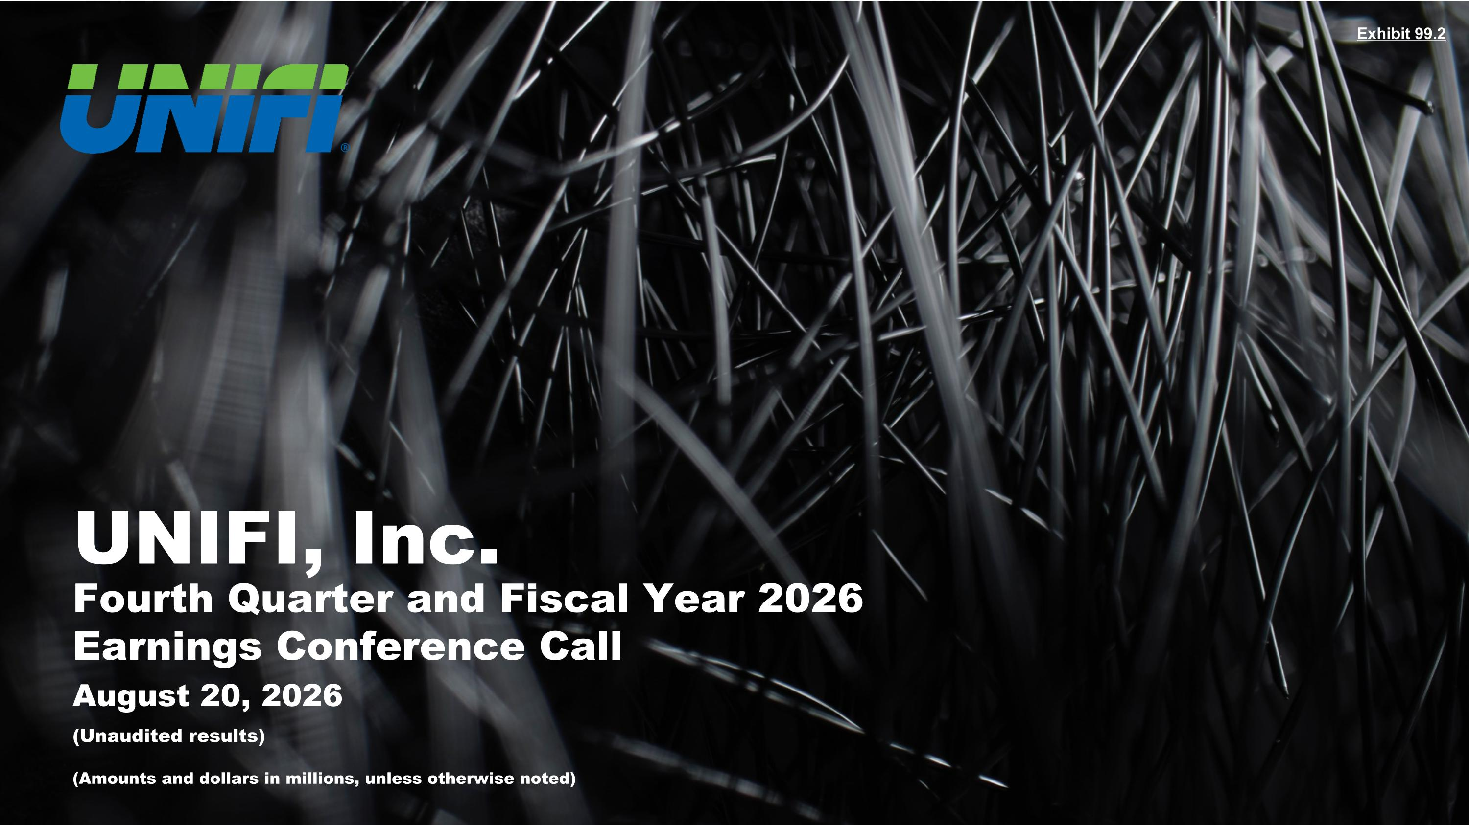
Exhibit 99.2 August 20, 2026 UNIFI, Inc. Fourth Quarter and Fiscal Year 2026 Earnings Conference Call (Unaudited results) (Amounts and dollars in millions, unless otherwise noted)

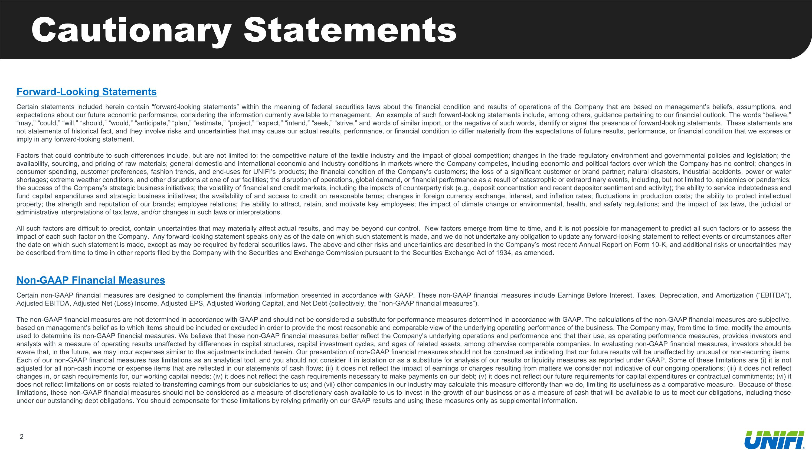
Cautionary Statements Forward-Looking Statements Certain statements included herein contain “forward-looking statements” within the meaning of federal securities laws about the financial condition and results of operations of the Company that are based on management’s beliefs, assumptions, and expectations about our future economic performance, considering the information currently available to management. An example of such forward-looking statements include, among others, guidance pertaining to our financial outlook. The words “believe,” “may,” “could,” “will,” “should,” “would,” “anticipate,” “plan,” “estimate,” “project,” “expect,” “intend,” “seek,” “strive,” and words of similar import, or the negative of such words, identify or signal the presence of forward-looking statements. These statements are not statements of historical fact, and they involve risks and uncertainties that may cause our actual results, performance, or financial condition to differ materially from the expectations of future results, performance, or financial condition that we express or imply in any forward-looking statement. Factors that could contribute to such differences include, but are not limited to: the competitive nature of the textile industry and the impact of global competition; changes in the trade regulatory environment and governmental policies and legislation; the availability, sourcing, and pricing of raw materials; general domestic and international economic and industry conditions in markets where the Company competes, including economic and political factors over which the Company has no control; changes in consumer spending, customer preferences, fashion trends, and end-uses for UNIFI’s products; the financial condition of the Company’s customers; the loss of a significant customer or brand partner; natural disasters, industrial accidents, power or water shortages; extreme weather conditions, and other disruptions at one of our facilities; the disruption of operations, global demand, or financial performance as a result of catastrophic or extraordinary events, including, but not limited to, epidemics or pandemics; the success of the Company’s strategic business initiatives; the volatility of financial and credit markets, including the impacts of counterparty risk (e.g., deposit concentration and recent depositor sentiment and activity); the ability to service indebtedness and fund capital expenditures and strategic business initiatives; the availability of and access to credit on reasonable terms; changes in foreign currency exchange, interest, and inflation rates; fluctuations in production costs; the ability to protect intellectual property; the strength and reputation of our brands; employee relations; the ability to attract, retain, and motivate key employees; the impact of climate change or environmental, health, and safety regulations; and the impact of tax laws, the judicial or administrative interpretations of tax laws, and/or changes in such laws or interpretations. All such factors are difficult to predict, contain uncertainties that may materially affect actual results, and may be beyond our control. New factors emerge from time to time, and it is not possible for management to predict all such factors or to assess the impact of each such factor on the Company. Any forward-looking statement speaks only as of the date on which such statement is made, and we do not undertake any obligation to update any forward-looking statement to reflect events or circumstances after the date on which such statement is made, except as may be required by federal securities laws. The above and other risks and uncertainties are described in the Company’s most recent Annual Report on Form 10-K, and additional risks or uncertainties may be described from time to time in other reports filed by the Company with the Securities and Exchange Commission pursuant to the Securities Exchange Act of 1934, as amended. Non-GAAP Financial Measures Certain non-GAAP financial measures are designed to complement the financial information presented in accordance with GAAP. These non-GAAP financial measures include Earnings Before Interest, Taxes, Depreciation, and Amortization (“EBITDA”), Adjusted EBITDA, Adjusted Net (Loss) Income, Adjusted EPS, Adjusted Working Capital, and Net Debt (collectively, the “non-GAAP financial measures”). The non-GAAP financial measures are not determined in accordance with GAAP and should not be considered a substitute for performance measures determined in accordance with GAAP. The calculations of the non-GAAP financial measures are subjective, based on management’s belief as to which items should be included or excluded in order to provide the most reasonable and comparable view of the underlying operating performance of the business. The Company may, from time to time, modify the amounts used to determine its non-GAAP financial measures. We believe that these non-GAAP financial measures better reflect the Company’s underlying operations and performance and that their use, as operating performance measures, provides investors and analysts with a measure of operating results unaffected by differences in capital structures, capital investment cycles, and ages of related assets, among otherwise comparable companies. In evaluating non-GAAP financial measures, investors should be aware that, in the future, we may incur expenses similar to the adjustments included herein. Our presentation of non-GAAP financial measures should not be construed as indicating that our future results will be unaffected by unusual or non-recurring items. Each of our non-GAAP financial measures has limitations as an analytical tool, and you should not consider it in isolation or as a substitute for analysis of our results or liquidity measures as reported under GAAP. Some of these limitations are (i) it is not adjusted for all non-cash income or expense items that are reflected in our statements of cash flows; (ii) it does not reflect the impact of earnings or charges resulting from matters we consider not indicative of our ongoing operations; (iii) it does not reflect changes in, or cash requirements for, our working capital needs; (iv) it does not reflect the cash requirements necessary to make payments on our debt; (v) it does not reflect our future requirements for capital expenditures or contractual commitments; (vi) it does not reflect limitations on or costs related to transferring earnings from our subsidiaries to us; and (vii) other companies in our industry may calculate this measure differently than we do, limiting its usefulness as a comparative measure. Because of these limitations, these non-GAAP financial measures should not be considered as a measure of discretionary cash available to us to invest in the growth of our business or as a measure of cash that will be available to us to meet our obligations, including those under our outstanding debt obligations. You should compensate for these limitations by relying primarily on our GAAP results and using these measures only as supplemental information.


Today’s Speakers Al Carey Executive Chairman Eddie Ingle CEO and Director A.J. Eaker EVP, CFO, and Treasurer

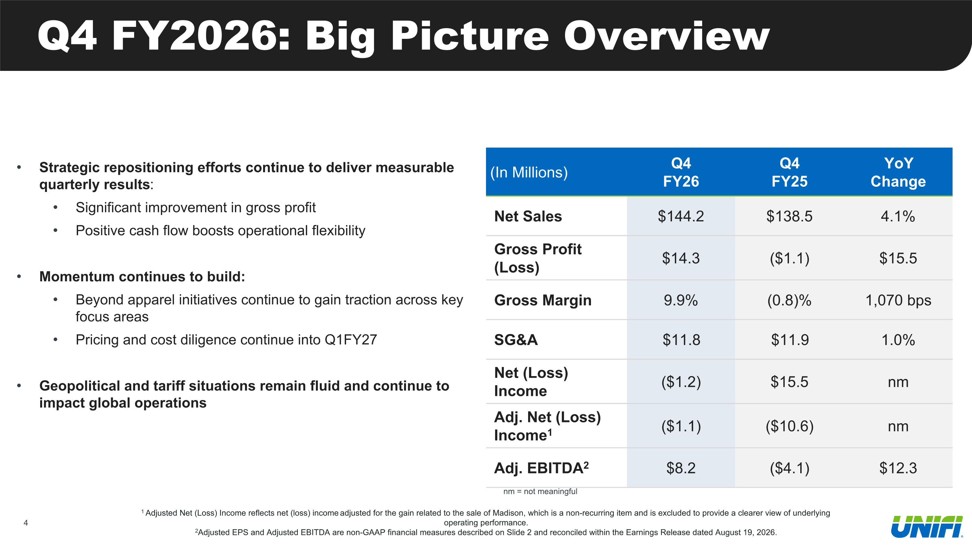
Q4 FY2026: Big Picture Overview Strategic repositioning efforts continue to deliver measurable quarterly results: Significant improvement in gross profit Positive cash flow boosts operational flexibility Momentum continues to build: Beyond apparel initiatives continue to gain traction across key focus areas Pricing and cost diligence continue into Q1FY27 Geopolitical and tariff situations remain fluid and continue to impact global operations 1 Adjusted Net (Loss) Income reflects net (loss) income adjusted for the gain related to the sale of Madison, which is a non-recurring item and is excluded to provide a clearer view of underlying operating performance. 2Adjusted EPS and Adjusted EBITDA are non-GAAP financial measures described on Slide 2 and reconciled within the Earnings Release dated August 19, 2026. (In Millions) Q4 FY26 Q4 FY25 YoY Change Net Sales $144.2 $138.5 4.1% Gross Profit (Loss) $14.3 ($1.1) $15.5 Gross Margin 9.9% (0.8)% 1,070 bps SG&A $11.8 $11.9 1.0% Net (Loss) Income ($1.2) $15.5 nm Adj. Net (Loss) Income1 ($1.1) ($10.6) nm Adj. EBITDA2 $8.2 ($4.1) $12.3 nm = not meaningful

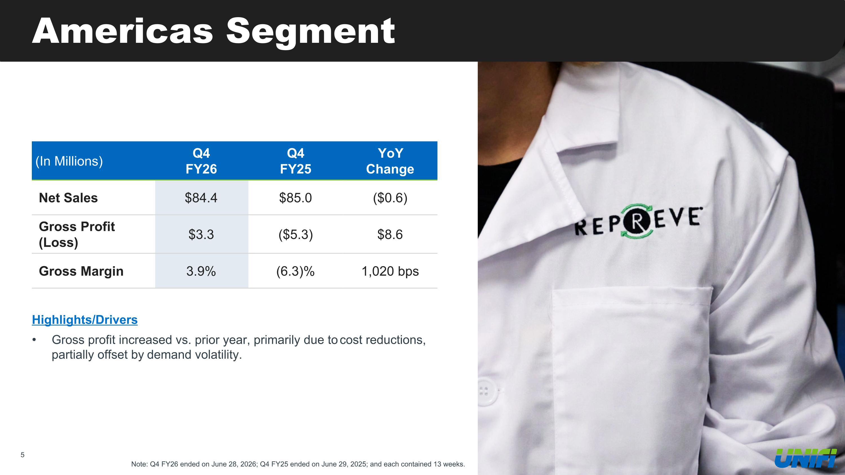
Americas Segment Note: Q4 FY26 ended on June 28, 2026; Q4 FY25 ended on June 29, 2025; and each contained 13 weeks. (In Millions) Q4 FY26 Q4 FY25 YoY Change Net Sales $84.4 $85.0 ($0.6) Gross Profit (Loss) $3.3 ($5.3) $8.6 Gross Margin 3.9% (6.3)% 1,020 bps Highlights/Drivers Gross profit increased vs. prior year, primarily due to cost reductions, partially offset by demand volatility.

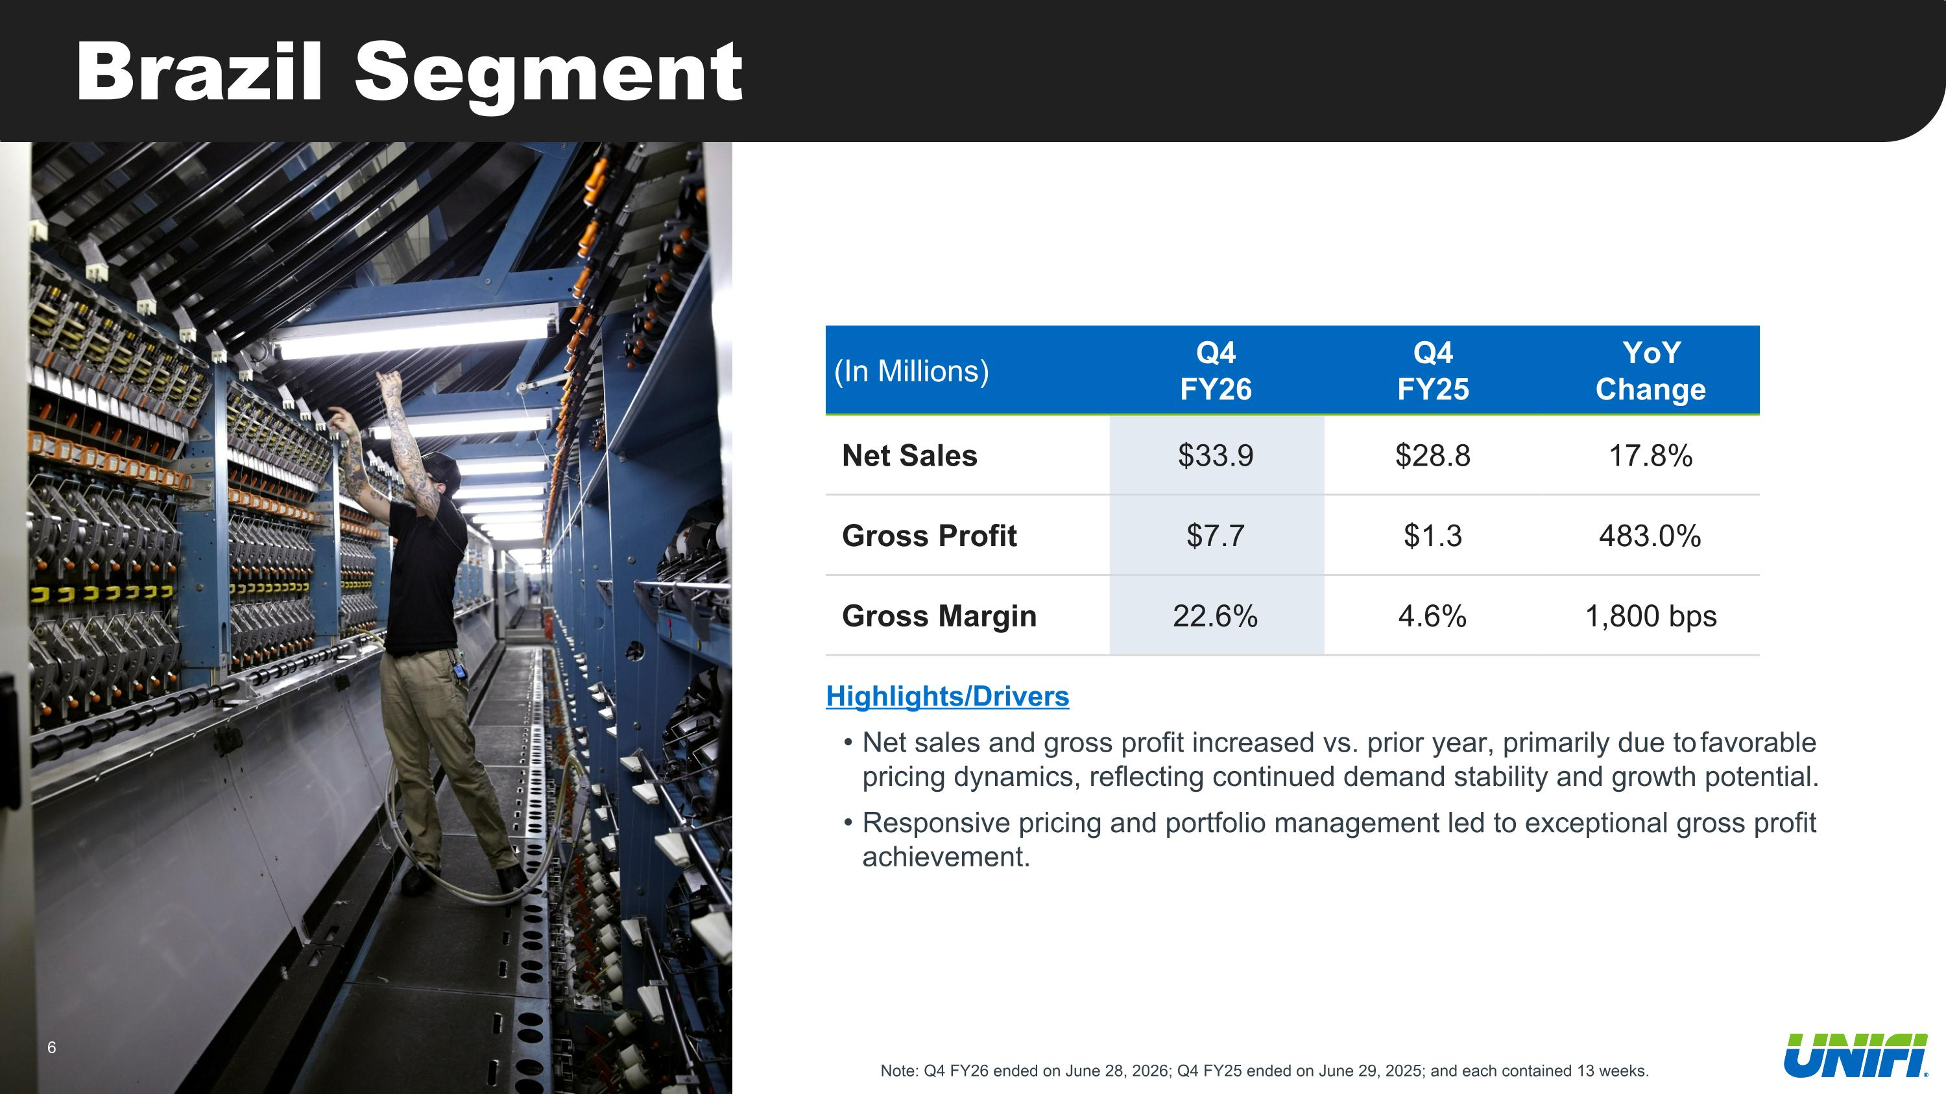
Brazil Segment (In Millions) Q4 FY26 Q4 FY25 YoY Change Net Sales $33.9 $28.8 17.8% Gross Profit $7.7 $1.3 483.0% Gross Margin 22.6% 4.6% 1,800 bps Highlights/Drivers Net sales and gross profit increased vs. prior year, primarily due to favorable pricing dynamics, reflecting continued demand stability and growth potential. Responsive pricing and portfolio management led to exceptional gross profit achievement. Note: Q4 FY26 ended on June 28, 2026; Q4 FY25 ended on June 29, 2025; and each contained 13 weeks.

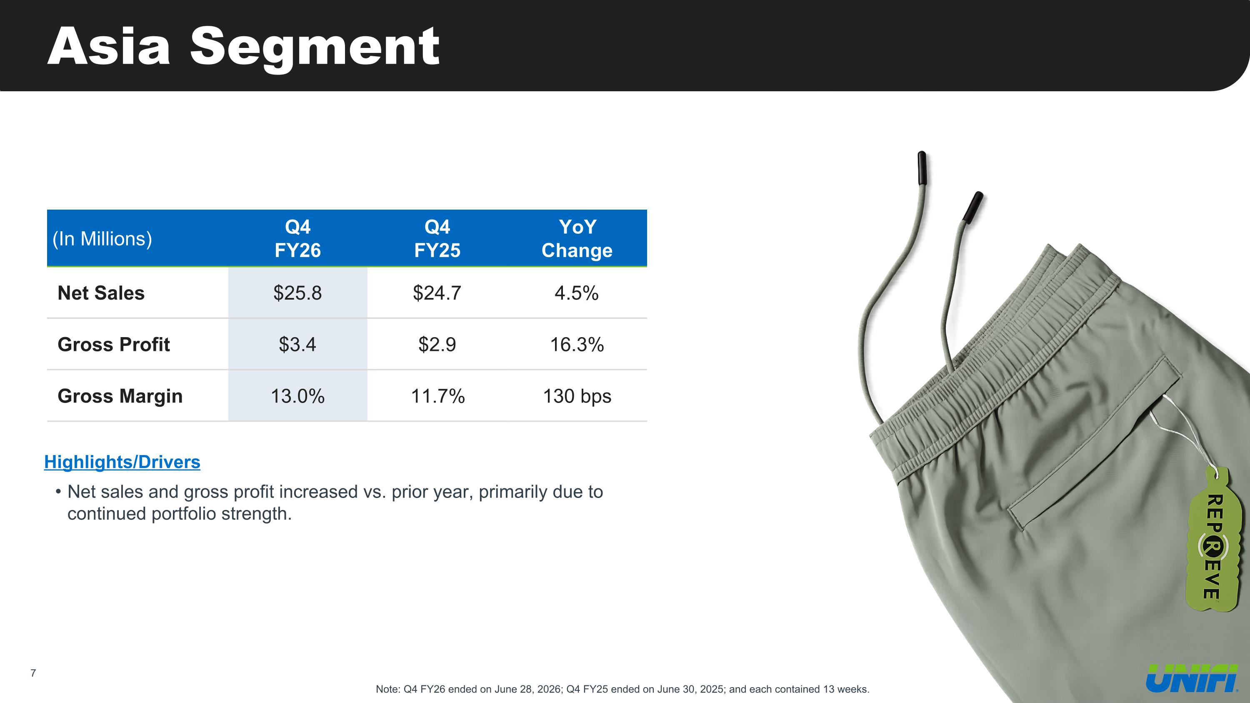
Asia Segment (In Millions) Q4 FY26 Q4 FY25 YoY Change Net Sales $25.8 $24.7 4.5% Gross Profit $3.4 $2.9 16.3% Gross Margin 13.0% 11.7% 130 bps Highlights/Drivers Net sales and gross profit increased vs. prior year, primarily due to continued portfolio strength. Note: Q4 FY26 ended on June 28, 2026; Q4 FY25 ended on June 30, 2025; and each contained 13 weeks.

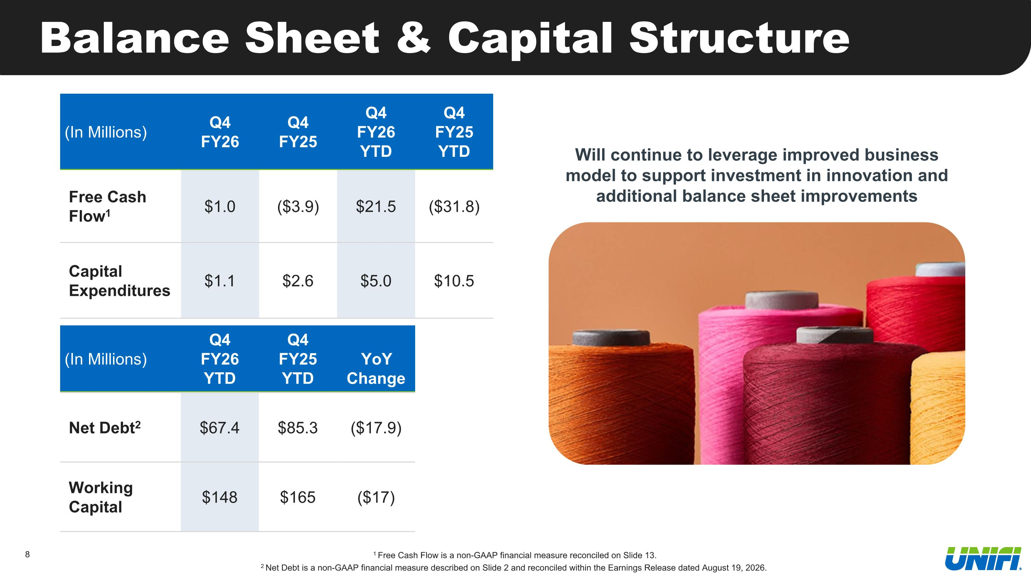
Balance Sheet & Capital Structure 1 Free Cash Flow is a non-GAAP financial measure reconciled on Slide 13. 2 Net Debt is a non-GAAP financial measure described on Slide 2 and reconciled within the Earnings Release dated August 19, 2026. (In Millions) Q4 FY26 Q4 FY25 Q4 FY26 YTD Q4 FY25 YTD Free Cash Flow1 $1.0 ($3.9) $21.5 ($31.8) Capital Expenditures $1.1 $2.6 $5.0 $10.5 Will continue to leverage improved business model to support investment in innovation and additional balance sheet improvements (In Millions) Q4 FY26 YTD Q4 FY25 YTD YoY Change Net Debt2 $67.4 $85.3 ($17.9) Working Capital $148 $165 ($17)

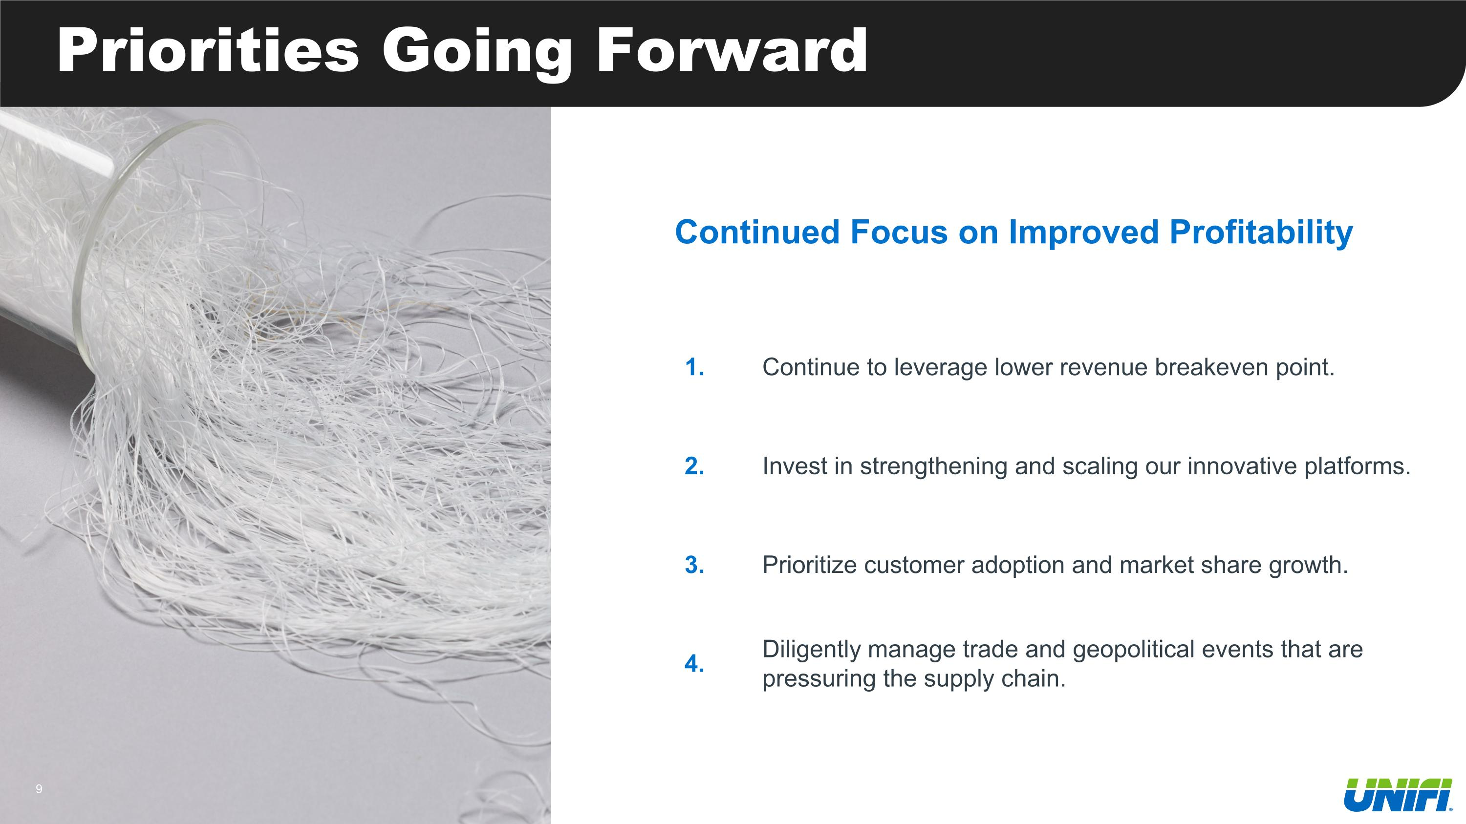
Priorities Going Forward 1. Continue to leverage lower revenue breakeven point. 2. Invest in strengthening and scaling our innovative platforms. 3. Prioritize customer adoption and market share growth. 4. Diligently manage trade and geopolitical events that are pressuring the supply chain. Continued Focus on Improved Profitability

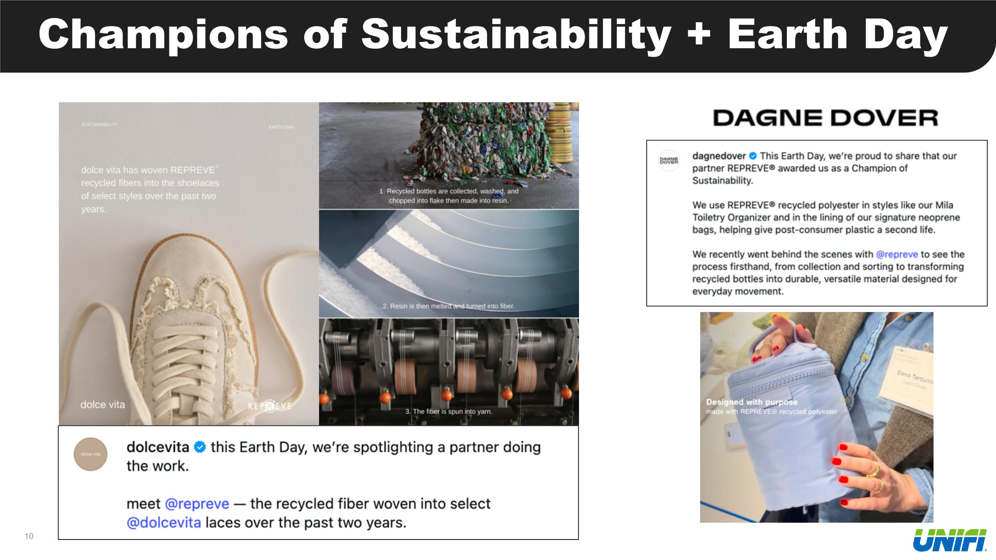
Champions of Sustainability + Earth Day

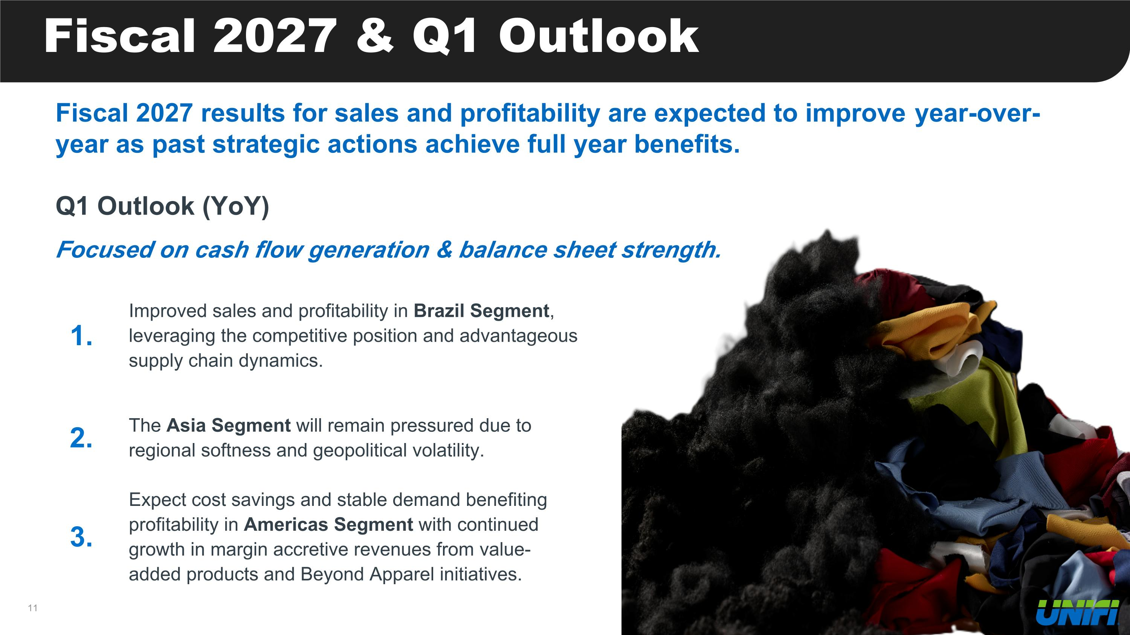
Fiscal 2027 & Q1 Outlook Fiscal 2027 results for sales and profitability are expected to improve year-over-year as past strategic actions achieve full year benefits. Q1 Outlook (YoY) Focused on cash flow generation & balance sheet strength. 1. Improved sales and profitability in Brazil Segment, leveraging the competitive position and advantageous supply chain dynamics. 2. The Asia Segment will remain pressured due to regional softness and geopolitical volatility. 3. Expect cost savings and stable demand benefiting profitability in Americas Segment with continued growth in margin accretive revenues from value-added products and Beyond Apparel initiatives.


Contact Investor Relations: UFI@alpha-ir.com

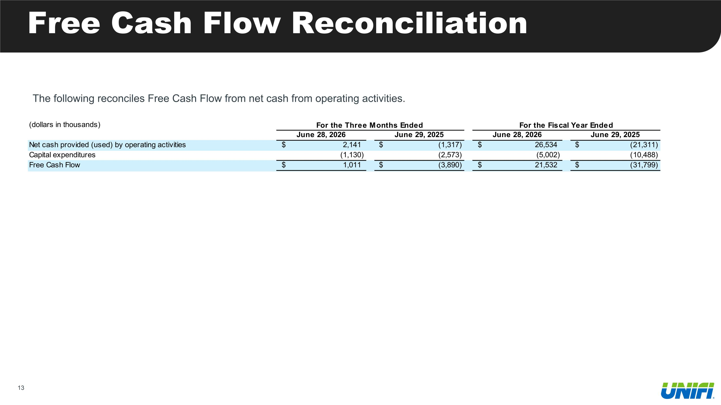
Free Cash Flow Reconciliation The following reconciles Free Cash Flow from net cash from operating activities.

