UNITED STATES
SECURITIES AND EXCHANGE COMMISSION
Washington, D.C. 20549
SCHEDULE 14A
Proxy Statement Pursuant to Section 14(a) of the
Securities Exchange Act of 1934
Filed by the Registrant ☒
Filed by a Party other than the Registrant ☐
Check the appropriate box:
☐ |  | Preliminary Proxy Statement
☐ |  | Confidential, for Use of the Commission Only (as permitted by Rule 14a-6(e)(2))
☐ |  | Definitive Proxy Statement
☒ |  | Definitive Additional Materials
☐ |  | Soliciting Material Pursuant to §240.14a-12
UNIFI, INC.
(Name of Registrant as Specified In Its Charter)
(Name of Person(s) Filing Proxy Statement, if other than the Registrant)
Payment of Filing Fee (Check the appropriate box):

☒ |  | No fee required.
☐ |  | Fee paid previously with preliminary materials.
☐ |  | Fee computed on table in exhibit required by Item 25(b) per Exchange Act Rules 14a-6(i)(1) and 0-11

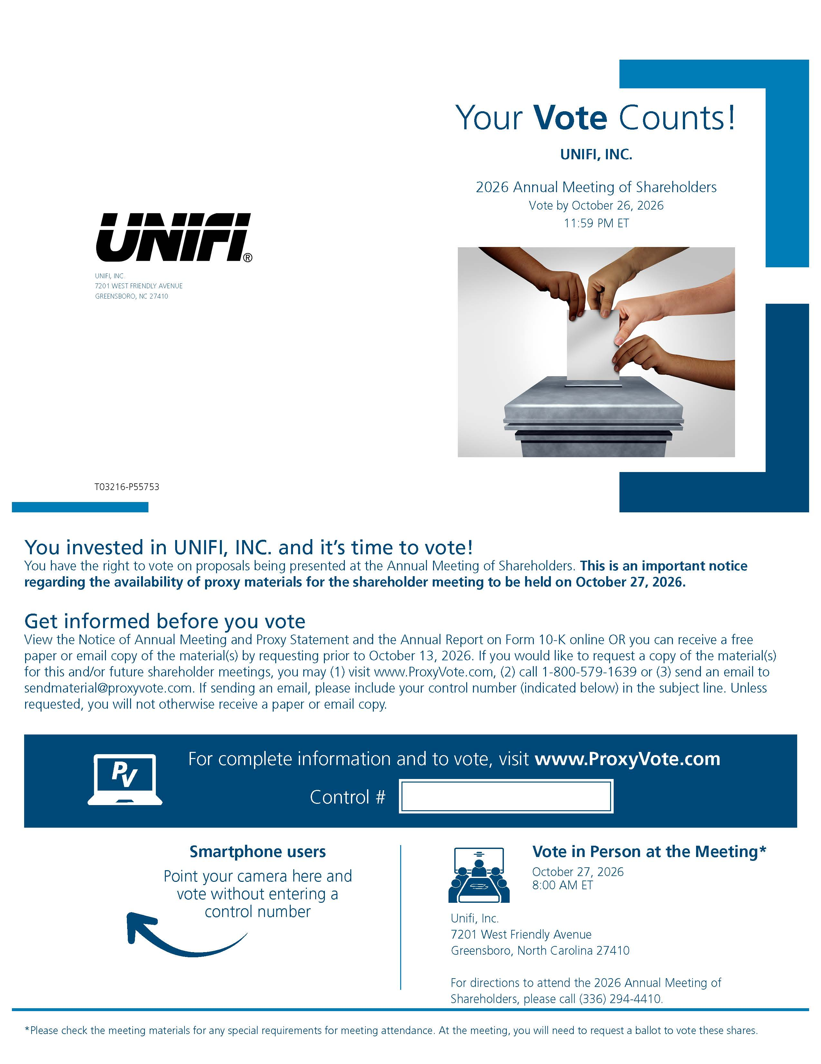
Your Vote Counts!UNIFI, INC.2026 Annual Meeting of ShareholdersVote by October 26, 202611:59 PM ETUNIFI, INC.7201 WEST FRIENDLY AVENUEGREENSBORO, NC 27410T03216-P55753You invested in UNIFI, INC. and it’s time to vote!You have the right to vote on proposals being presented at the Annual Meeting of Shareholders. This is an important notice regarding the availability of proxy materials for the shareholder meeting to be held on October 27, 2026.Get informed before you voteView the Notice of Annual Meeting and Proxy Statement and the Annual Report on Form 10-K online OR you can receive a free paper or email copy of the material(s) by requesting prior to October 13, 2026. If you would like to request a copy of the material(s) for this and/or future shareholder meetings, you may (1) visit www.ProxyVote.com, (2) call 1-800-579-1639 or (3) send an email to sendmaterial@proxyvote.com. If sending an email, please include your control number (indicated below) in the subject line. Unless requested, you will not otherwise receive a paper or email copy.For complete information and to vote, visit www.ProxyVote.com Control #Vote in Person at the Meeting*October 27, 20268:00 AM ETSmartphone usersPoint your camera here and vote without entering a control numberUnifi, Inc.7201 West Friendly AvenueGreensboro, North Carolina 27410For directions to attend the 2026 Annual Meeting of Shareholders, please call (336) 294-4410.*Please check the meeting materials for any special requirements for meeting attendance. At the meeting, you will need to request a ballot to vote these shares.

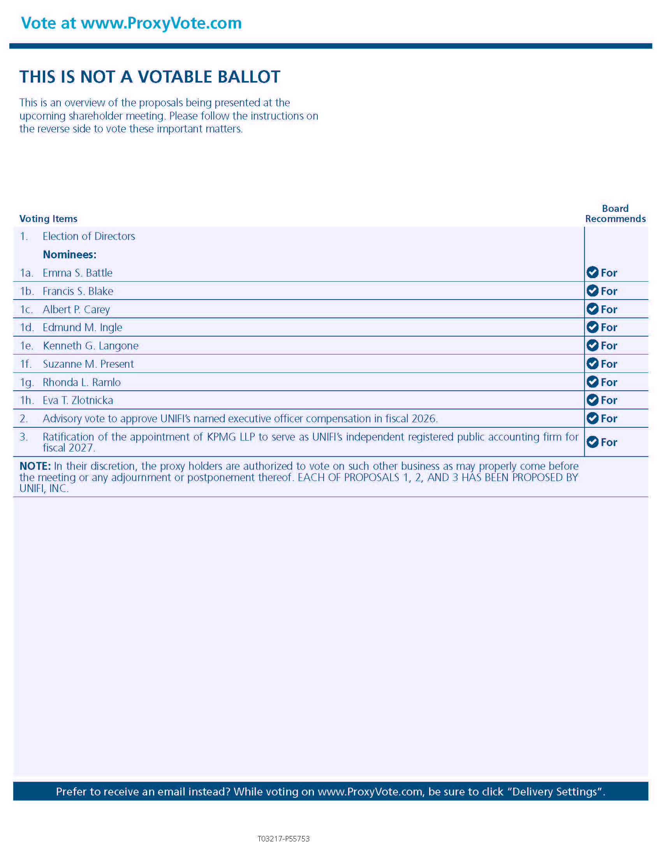

Vote at www.ProxyVote.comTHIS IS NOT A VOTABLE BALLOTThis is an overview of the proposals being presented at the upcoming shareholder meeting. Please follow the instructions on the reverse side to vote these important matters.Board Voting ItemsRecommends1.Election of DirectorsNominees:1a.Emma S. BattleFor1b.Francis S. BlakeFor1c.Albert P. CareyFor1d.Edmund M. IngleFor1e.Kenneth G. LangoneFor1f.Suzanne M. PresentFor1g.Rhonda L. RamloFor1h.Eva T. ZlotnickaFor2.Advisory vote to approve UNIFI’s named executive officer compensation in fiscal 2026.For3.Ratification of the appointment of KPMG LLP to serve as UNIFI’s independent registered public accounting firm for fiscal 2027.ForNOTE: In their discretion, the proxy holders are authorized to vote on such other business as may properly come before the meeting or any adjournment or postponement thereof. EACH OF PROPOSALS 1, 2, AND 3 HAS BEEN PROPOSED BY UNIFI, INC.Prefer to receive an email instead? While voting on www.ProxyVote.com, be sure to click “Delivery Settings”.T03217-P55753

